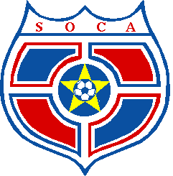

Youth Event: July 19, 2025 Team Fee: $225.00 Adult Event: July 20, 2025 Team Fee: $250.00

Tournament Registration/Roster/Fee deadline: Monday, July 7th, 2025 Roster Freeze: Thursday, July 17th, 2025
Roster: min 7, max 10 – Boys & Girls Divisions U10(2015,16), U12(2013,14), U15 (2010-12) U19 (2006-9) divisions offered.
Deliver registration and tournament fee to: SOCA 1685 Polo Grounds Road, Charlottesville, VA 22911
Or email registration to Bobby.Lutz@socaspot.org and pay fee by credit card or check

Team Name(Be Creative) | Tournament Division (ex: U12 Boys, U15 Girls, Over 40, Co-rec Adults)

# | Player Name |  | Date of Birth | Fall team (example U12 Girls Red, U15 Boys Blue, En Fuego, Walking Wounded etc…) Fall 25 team ages used. | E-Mail
# | Last | First | Date of Birth |  | E-Mail
1
2
3
4
5
6
7
8
9
10

Primary Team Contact | Alternate Team Contact
Name | Name
Phone Number | Phone Number
Email Address | Email Address
Tournament Director: Bobby Lutz Bobby.Lutz@socaspot.org (434)975-5025 x112

