SOCA

Soccer Organization of Charlottesville



Recreational Program

Coaches Handbook
Spring 2022

THE ANNUAL SOCA RECREATIONAL PROGRAM
SUNBURN TOURNAMENT

TOURNAMENT RULES

The tournament will be held over the weekend of May 28th & 29th, 2022. The standard rules for SOCA Recreational Program play will prevail except as specifically amended herein, for the tournament.

Inclement weather prior to the start date will terminate the tournament. If the tournament is canceled prior to the start, full refunds will be returned. Cancellation during the tournament will result in prorated refunds. Withdrawal during the tournament or expulsion of any team will result in no refund.

PURPOSE
The Sunburn Tournament is conducted for the enjoyment of the players. SOCA’s goal is to provide recreational players the opportunity to showcase their skills and experience a tournament setting. Players, coaches, and spectators are encouraged to enjoy the fun and challenge of the tournament format. The tournament is intended to be a safe, fun and developmentally challenging experience for all participants.

Participating teams and spectators are expected to exhibit the highest standards of sportsmanship. If, in the opinion of the Tournament Director, the conduct of a team, its coaches, or supporters does not meet these expectations, that team may be prevented from participating further in the tournament. There will be no refunds in the event of such an expulsion.

GENERAL INFORMATION
LOCATIONS:
The Tournament will be played at various fields at the SOCA-ACAC South Fork Soccer Park, SOCA Fieldhouse and other Albemarle locations.

REFEREE AND LINESMAN:
For this tournament, a three official system will be used for all matches, other than U-10 matches. For U-10 matches a center referee will be assigned, and each participating team must provide one volunteer assistant referee. The volunteer assistant referee will provide assistance on “out of bounds” calls only. For all other matches a center referee and two assistant referees will be assigned.

As per the Laws of the Game, the referee’s authority commences upon his/her arrival at the field of play. All decisions of the referee are final and binding. There are no protests and no appeals.

TOURNAMENT DIRECTOR:
The Tournament Director is the final authority on all matters pertaining to the tournament. All decisions are final. There are no protests and no appeals. The Tournament Director may appoint duly authorized persons to assist with tournament operations at various fields and venues.

SCHEDULING:
All teams are obligated to play all games as scheduled. NO scheduling changes will be made, except as indicated by the Tournament Director. Failure to play any game as scheduled will result in a forfeit of the scheduled match, by the team unable to fulfill their obligation.

All matches will begin on time. There is no grace period. All teams are expected to report to the proper playing field a minimum of 15 minutes prior to the scheduled start of their match for warm-up and roster verification. Any team unable to field the minimum (7 for 11v11 matches, 6 for 8v8 matches, and 4 for 6v6 matches) allowable players at the appointed start time will forfeit the match. The referee shall determine a team’s preparedness at the scheduled start time. Forfeiture shall be declared to the teams’ coaches and reported to the Tournament Director.

FORMAT:
Age groupings and division alignments are provided, attached. All teams are guaranteed a minimum of three games.

Division standings will be decided upon the following basis:
Win = 3 points
Tie = 1 point
Loss = 0 points
Ties in placement among divisional opponents will be broken according to the rules listed below.

PLAYING TIME:
The requirement for each player to participate in at least one half of every match applies. Teams failing to comply with the spirit of this policy will face possible forfeiture of matches.

TEAM SIZE:
All teams participating in the tournament are expected to field full teams. The standard Recreational Program procedure of “playing down” to keep both teams at even numbers at the start of games will be waived for the tournament. Any team unable to start a match with a full compliment of players is nonetheless expected to play, realizing they will be playing shorthanded.

ELIGIBILITY:
Only current SOCA registered Recreational players may participate in the tournament. These players may play only for the team to which they have been assigned by SOCA. Official SOCA rosters shall determine the eligible players for each team. At U10 & U12 a maximum of three guest players and at U14 & U18 a maximum of five guest players are permitted on each team. Guest players must be officially registered to a SOCA team. All players must have been registered prior to the tournament application deadline.

The Tournament Director, Field Marshals and Match Officials have the authority to verify the identification of all eligible players prior to the start of each match. Participation of unregistered players will result in the forfeit of any games in which they participated.

FORFEIT:
Any team forfeiting a match shall be declared the loser by a score of 3-0.

SEPARATION OF TEAMS AND SPECTATORS:
Teams and spectators shall occupy opposite sidelines at each match. The “team” and “spectator” side of each field is designated in the enclosed field location map. Players and coaches only are permitted onto the “team” side of the field.

GAME TIE BREAKING PROCEDURES:
All preliminary round matches ending in a tie at the end of regulation play, shall remain as ties.

In semi-final and final matches only the following shall apply: if teams are tied at the end of regulation time, two five minute “Golden Goal” overtime periods will be played. The first team to score, regardless of time remaining, wins. There will be a two-minute break between overtime periods. Teams switch ends following the interval.

If the game remains tied at the end of the second period, the winner will be determined using FIFA Penalty Kick procedures. Only players on the field at the conclusion of the second overtime period will be permitted to participate in the penalty kicks.

GROUP STANDINGS TIE-BREAKING PROCEDURES:
- Fewest penalty points in all games played. Yellow card = 1 point, red card = 2 points.
- Results of head-to-head competition. Disregard if more than two teams are tied.
- Goal differential in all preliminary games. Maximum 4 goal difference per game.
- Least goals allowed in all preliminary games.
- Most goals scored in all preliminary games regardless of goal differential.
- If both teams are still tied after steps 1-5, both teams will proceed to an available field, at a time and place determined by the Tournament Director. Here, a FIFA Penalty Kick procedure will be followed to determine a winner.
- In instances where ties must be broken to determine seeding but the result does not have a direct impact on the division championship, a coin flip by the Tournament Director will be substituted for step #6.

If a three-way tie exists, the tie-breaking rules will be followed in order until one team is determined to be the higher seed. A two-way tie between the two remaining teams will be decided beginning at step 1.

HOME TEAM:
The home team is listed first in the schedule. The home team shall provide the game ball. In the event that both teams in a match are wearing the same color, the home team shall wear pinnies provided by SOCA.

AWARDS:
Awards will be provided to the first and second place team in each age group. Awards will be presented at Tournament HQ.

THE LAWS OF THE GAME

All matches shall be played in accordance with FIFA/USYSA Laws except as specifically modified herein.

LAW I - THE FIELD:
U-10 shall play on approximately 60x40 yard fields & U-12 shall play on approximately 80x55 yard fields.

U-14, U16, U-18 shall play on fields meeting FIFA minimum standards for full-sized fields.

LAW II - THE BALL:
U-10 and U-12: size 4.
U-14 thru U-18: size 5.

LAW III - NUMBER OF PLAYERS:
U-10: 6v6
U-12: 8v8
U-14, U16, and U-18: 11v11.

Unlimited substitution will be allowed, with the permission of the referee, at the following times:
- By either team, after a goal has been scored.
- By either team, prior to a goal kick.
- By either team, when the referee stops the match for an injury.
- By either team at half time.
- By either team at the start of an overtime period.
- By the team in possession of the ball, prior to a throw-in.
- Upon the issuance of a caution (yellow card), for the cautioned player only. Any player receiving a caution (yellow card) must be substituted, and may re-enter the game at the next legal opportunity.

All substitutes shall inform the assistant referee that they wish to enter the game. All substitutions shall take place at the mid-field line. The assistant referee will signal the referee that substitutes wish to enter at the first opportunity and that the substitutes are entitled to enter the game. Players may only enter the field at the signal of the referee. Play of the game will not be interrupted to allow for substitutes to enter the game who have not first informed the assistant referee that they wish to enter the game.

LAW IV - PLAYERS’ EQUIPMENT:
All players shall wear their current SOCA issued uniforms. In the event of teams wearing the same colors, SOCA will provide pinnies to be worn by the “home” team.

All players shall wear shin guards.

Players will not be allowed to play if they are wearing anything dangerous to themselves or to other players, such as jewelry. Eyeglass hinges must be covered. Players with a cast maybe permitted to play if in the opinion of the referee it is properly padded.

As always, the referee has final discretion concerning what is permissible on the field of play.

LAW VII - DURATION OF THE GAME:
Due to the tight schedule, all games will begin on time, as scheduled.
U-10: two 25 minute halves, 5 minute interval.
U-12: two 30 minute halves, 5 minute interval.
U-14 & U16: two 35 minute halves, 5 minute interval.
U-18: two 40 minute halves, 5 minute interval.

The game clock will be the sole responsibility of the referee and will run continuously. There will be no added time for substitutions or injuries unless a rescue squad must be summoned to move an injured player.

The Tournament Director will determine whether or not matches shall be stopped because of dangerous weather conditions. If such a decision is made, it will apply to all matches. If the first half of any match has been completed at the time tournament play has been suspended, the score of the match shall stand as the final score. If the first half of a match has not been completed, the match result may stand, or the match may be resumed, starting with the second half kick-off, at a time to be determined by the Tournament Director.

LAW XI - OFFSIDES:
There is no off-side offense for U-10 play.

LAW XII - FOULS AND MISCONDUCT:
Any player ejected (red card) from a match shall not be allowed to participate in his/her team’s next scheduled match.

Any coach who is ejected will not be allowed to participate further in the tournament.

Any player or coach who receives three yellow cards during the tournament will not be allowed to participate in their team’s next scheduled match.

It is the responsibility of the coach to hold out players who are suspended from a game. The use of a suspended player will result in the forfeiture of that match and disqualification of the team from further participation in the tournament.

Coaches are responsible for the behavior of their players and their supporters. No player, coach, or spectator shall enter the field of play regardless of the circumstances, unless that person has been given permission to enter the field by the referee.

Any instance of a red card being issued after the end of regulation play, or as a result of physical assault, or for an incident involving serious foul play or violent conduct, is subject to review by the Tournament Director and the SOCA Conduct Committee. Such action may result in a more strenuous penalty than the standard punishments that result from a red card.

For the U-10 division:

- There is no off-side offense.
- No Heading Rule is in effect.
  - The result of an intentional head ball is an indirect kick for the other team. The result of an unintentional head ball will result in a drop-ball restart.
  - Referees may ask for a player to leave the game to be evaluated for concussion symptoms.
- No Punting Rule is in effect.
  - Goalkeepers will not be allowed to punt or drop-kick the ball.
  - If a Goalkeeper punts the ball the restart will be an indirect free kick from the spot that the Goalkeeper had made the offense.
- A Build-Out Line will be in effect.
  - When the Goal Keeper has possession of the ball, the opposing team will need to retreat back behind build out line. (See image below).
  - When the ball is put into play, the opposing team will be allowed to attack.

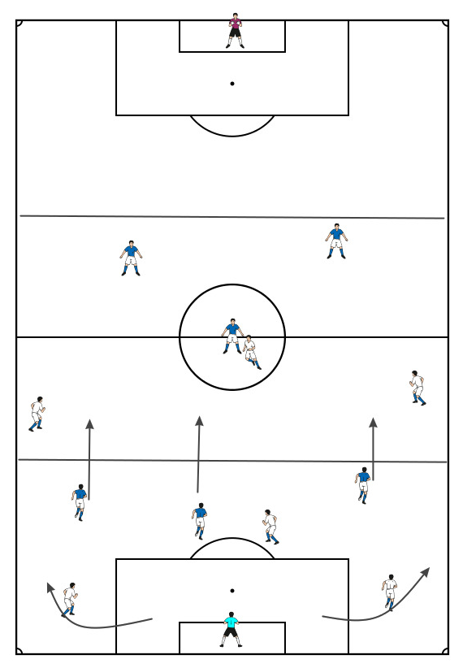

OTHER IMPORTANT ITEMS OF INTEREST

1. Coaches are required to initial the official game card at the conclusion of each match. Initialed game cards will certify the result. Referees shall provide the game cards for initialing at the match conclusion. Initialed game cards are returned to the referee. The referee must submit the game cards to the Tournament Director in a timely manner.

2. Referees will begin the game clock at the scheduled start time. Matches must begin on time, as scheduled. There is no leniency for late starts.

3. Pairings for the second day of competition will be posted at the tournament sites, on www.SOCAspot.org under the tournament page and on the SOCA Weather Line, at 817-7246.

4. PLEASE keep the tournament sites clean! Enlist the help of your players and parents to pick up and properly discard all trash.

GOOD LUCK TO ALL! HAVE A GREAT TOURNAMENT EXPERIENCE

PROCEDURE FOR TAKING KICKS FROM THE PENALTY MARK
- The referee chooses the goal at which the kicks will be taken
- The referee tosses a coin and the team whose captain wins the toss decides whether to take the first or second kick
- The referee keeps a record of the kicks being taken
- Subject to the conditions explained below, both teams take five kicks
- The kicks are taken alternately by the teams
- If, before both teams have taken five kicks, one has scored more goals than other could score, even if it were to complete its five kicks, no more kicks are taken
- If, after both teams have taken five kicks, both have scored the same number of goals, or have not scored any goals, kicks continue to be taken in the same order until one team has scored a goal more than the other from the same number of kicks
- A goalkeeper who is injured while kicks from the penalty mark are being taken and is unable to continue as goalkeeper may be replaced by a named substitute provided his team has not used the maximum number of substitutes permitted under the competition rules
- With the exception of the foregoing case, only players who are on the field of play at the end of the match, which includes extra time where appropriate, are allowed to take kicks from the penalty mark
- Each kick is taken by a different player and all eligible players must take a kick before any player can take a second kick
- An eligible player may change places with the goalkeeper at any time when kicks from the penalty mark are being taken
- Only the eligible players and match officials are permitted to remain on the field of play when kicks from the penalty mark are being taken
- All players, except the player taking the kick and the two goalkeepers, must remain within the centre circle
- The goalkeeper who is the team-mate of the kicker must remain on the field of play, outside the penalty area in which the kicks are being taken, on the goal line where it meets the penalty area boundary line
- Unless otherwise stated, the relevant Laws of the Game and International F. A. Board. Decisions apply when kicks from the penalty mark are being taken
- If, at the end of the match and before kicks start to be taken from the penalty mark, one team has a greater number of players that its opponents, it must reduce its number to equate with that of its opponent and the team captain must inform the referee of the name and number of each player excluded. Any player thus excluded may not participate in the kicks from the penalty mark.
- Before the start of kicks from the penalty mark the referee shall ensure that only an equal number of players from each team remain within the centre circle and they shall take the kicks.

Copied from FIFA “Laws of the Game”

